Medical Staff Office
One Hurley Plaza
Flint, Michigan 48503
Phone: (810) 262-9239
Fax: (810) 262-9249

Dear Applicant:

We would like to take a moment to thank you for your interest in joining the medical staff of Hurley Medical Center. At Hurley Medical Center, we are committed to our mission of Clinical Excellence, Service to People, which we could not accomplish without the support and dedication of high caliber clinicians. We look forward to working along with you in this journey of performance excellence and are confident that together our efforts will make a significant difference in the lives of patients and families throughout Michigan.

We are excited to be offering you a more convenient way to obtain and submit your application for membership and privileges.

Please use the check off sheet provided to assist you in the successful completion of all elements of the application packet.

Upon receipt of all of the items indicated on the checklist, the hospital will verify your training, experience and request information from your references.

To expedite processing, it would be helpful if you would follow-up with your listed references and affiliations and request that they respond timely to our requests. During this review period, we will contact you if we require further information concerning your application. We will also periodically contact you and provide an update on the status of the credentialing process.

If there are any questions, feel free to call the Medical Staff Office at (810) 262-9239. Thank you!

Sincerely,
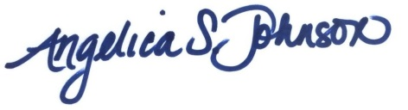

Angelica S. Johnson
Medical Staff Coordinator

Enclosures

