 | 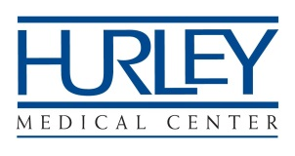  Medical Staff Office  Ph: (810) 262-9239  Fx: (810) 262-9249 | INVOICE
 | To: Prospective Professional Staff Member
DESCRIPTION |  |  |  | AMOUNT
Non-Refundable Application Fee for Professional Staff Membership |  |  |  | $200.00
TOTAL |  |  |  | $200.00

Make all checks payable to Hurley Medical Center
Payment is due with your application

Thank You!

