In the address bar of your Internet browser Type http://hurleymc.com. Scroll to the bottom of the screen and Select “Staff Portal”
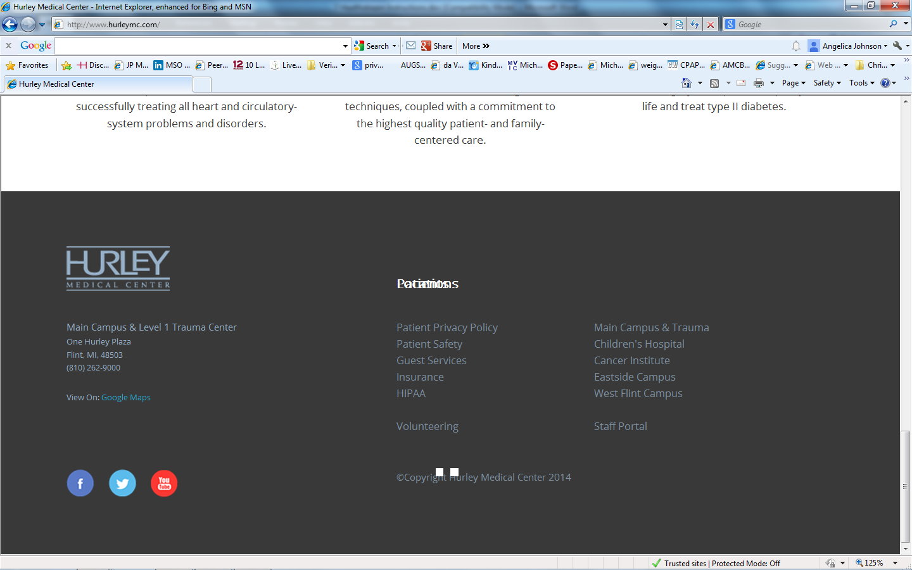
Select
“Staff Portal”

Scroll to the middle of the screen and Select the Red icon “HealthStream Learning Center”.
Select
“HealthStream Learning Center”

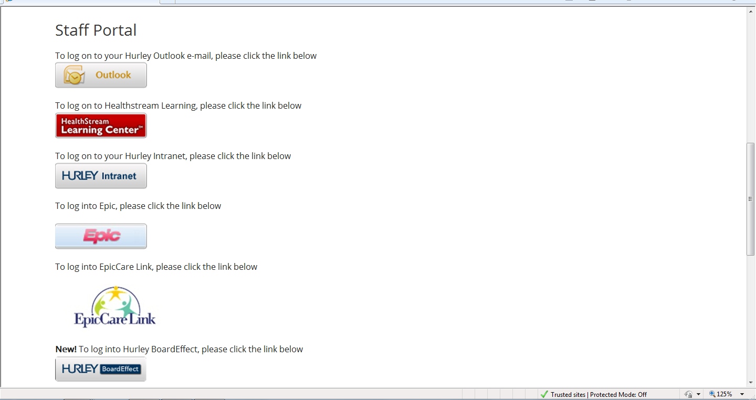
If you want to connect directly enter http://healthstream.com/hlc/hurleymc
in the address bar of your Internet browser.

Once you have HealthStream up on your screen you may sign-on using the first four letters of your last name and the last four numbers of your social security number.
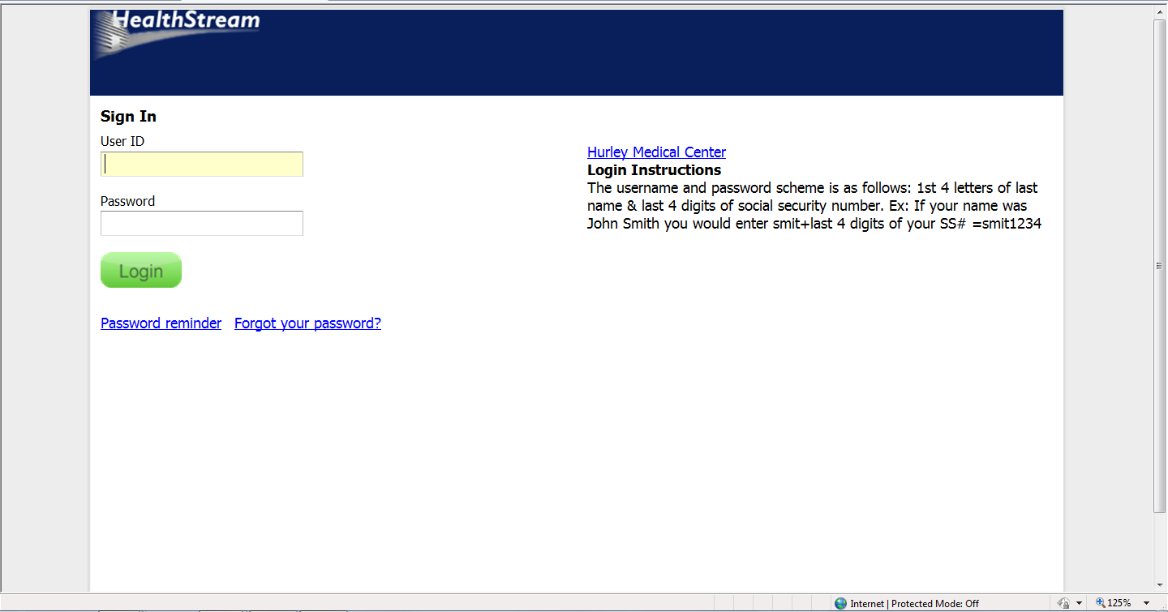

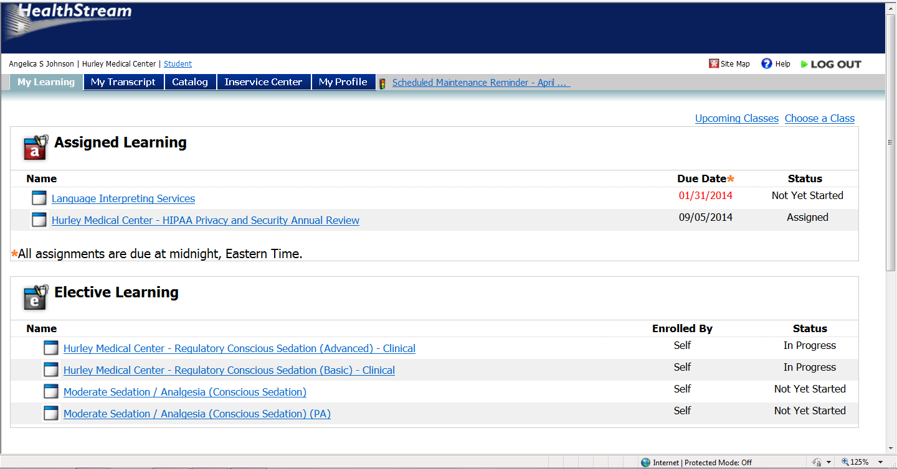
Courses are assigned to everyone and they are accessible on the first screen under “Assigned Learning” or by going to the “My Learning” tab. Click on the name of the course to begin your course.

Hurley Medical Center requests that all Assigned Learning modules be completed before receiving access to our Patient Information systems.

When finished you may print your certificates.

If you have any questions about HealthStream, please call Jamal at (810) 262-6314 (before 3:30 p.m.). If you have any questions regarding the credentialing process, please call the Medical Staff Office at (810) 262-9239.

